FEDERATION CYNOLOGIQUE INTERNATIONALE (AISBL)
Place Albert 1er, 13 – B – 6530 Thuin, tel : +32.71.59.12.38, fax : +32.71.59.22.29, internet: http://www.fci.be

REGULATIONS FOR FCI FLYBALL TOURNAMENTS
CONTENTS

Article I. GENERAL 2
Section 1.01 Validity 2
Section 1.02 General 2
Section 1.03 Definitions 2
Section 1.04 General criteria 2
Section 1.05 Preparation of the field 3
Section 1.06 Start permissions and exemption of jump height 3
Section 1.07 Participation 4
Section 1.08 Registration for tournaments 4
Section 1.09 Division-classification 4
Section 1.10 Composition and statement of team 4
Section 1.11 Jump Height 5
Section 1.12 FCI World record 5
Article II. ORGANISATION OF TOURNAMENTS 5
Section 2.01 Duties of the organizer 5
Section 2.02 Duties of the head judge 6
Section 2.03 Duties of the line judges 6
Section 2.04 Duties of the box judges: 6
Section 2.05 General competition rules 7
Article III. KINDS OF COMPETITIONS 8
Section 3.01 Round Robin (RR) 8
Section 3.02 Speed Trial (ST) 8
Section 3.03 Single (SE) or Double elimination (DE) 8
Section 3.04 Number of heats 8
Article IV. DESCRIPTION OF THE MATERIAL 9
Section 4.01 Jumps 9
Section 4.02 Flyball box (see annex 2) 9
Section 4.03 Balls 9
Section 4.04 Accessories 9
ANNEX 1 Preparation of Ring 10
ANNEX 2 Flyball box 11
ANNEX 3 Measurement 12
ANNEX 4 Technical description electronic judging system EJS 13
ANNEX 5 World record form - application 15

Article I. GENERAL

Section 1.01 Validity
(a) | These regulations were approved by the F.C.I. General Committee in …….. on ……
(b) | The regulations were written in English language. In case of uncertainty, the English text takes precedence over other translations.

Section 1.02 General
(a) | Flyball is a discipline in which 2 teams race each other in a relay-way. Each team consists of 4 combinations dog/handler, with 2 possible substitute combinations. Each race the two teams are competing against each other where each dog has to run over the four hurdles without help, trigger the ball from the flyball box and return with the ball over the same four hurdles. If the dog makes a possible mistake, he has to rerun. The team of which the four dogs have run the whole circuit without making any mistake is the winner of that heat.
(b) | This discipline is open to all dogs and promotes, in a playful way, the relationship between dog and handler. Most important aspects are the speed, the playfulness and the fetching of the ball, with an accent on safety and the prevention of injuries.
(c ) | The National Canine Organizations (N.C.O.) are asked to encourage the practicing of flyball in the spirit of and according to the regulations of the F.C.I. The main purpose of the F.C.I. rules is to set a standard for international tournaments and should be used to standardize international F.C.I. events, international judging guidelines and equipment standards. N.C.O.’s should use them as a basis for developing their own rules and regulations differing only to accommodate local needs.

Section 1.03 Definitions
(a) | Tournament: An event where clubs and teams compete, using agreed rules, format and regulations
(b) | Tournament part: A tournament can be split in various parts such as morning and afternoon, preliminary round and final round, etc. This is a clearly defined number of races.
(c) | Race: Each time when two teams have to race each other, there is a new race. It starts when the previous team has left the field and ends when the running teams leave the field.
(d) | Heat: Each race consists of a number of heats. A heat is one session where the four dogs run from the start until the judge blows the final whistle. If a heat has to be run again, the two runs will be considered as one heat.
(e) | Ring: The area in which flyball racing occurs. This area includes the racing lanes, from the backstops to the start/finish lines, the start/exit zone and the required clearances beside the racing lanes and the start/exit zone.
(f) | Breakout: when a team, during competition, runs faster than the fastest allowed time for the division in which it is competing.
(g) | Electronic Judging System (EJS): System that is used for judging the competition (see full description annex 4)

Section 1.04 General criteria
(a) | For each ring at which competitions will take place, at least one head judge appointed by the organizing association has to act.
(b) | Only head judges appointed by a N.C.O. are eligible to serve as official jury.
(c) | The head judges decide autonomously in the division(s) for which its competence applies. They always take their decisions in function of the valid regulations. Possible unsuspected cases will be solved in the spirit of the directives and regulations.
(d) | Each head judge will be completed with at least 2 line judges and 2 box judges per ring.

Section 1.05 Preparation of the field
(a) | A complete racing lane from start to flyball box measures 15.55 meters. (The dimensions were originally prepared in inches and have been converted to the metric system to 2 decimals.) - see annex 1
(b) | The distance from the start to the first hurdle is 1.83 meters. Between two consecutive hurdles, the distance is 3.05 meters. The distance from the last hurdle to flyball box is 4.57 meters.
(c) | When setting up the ring, the two lanes have to be at the exact same length and they have to be prepared parallel to each other. The distance between the two lanes is 5 meters (with a max. deviation of 1 meter) from centre to centre of each lane.
(d) | The surface has to be safe and not sliding, and may by no means be a rough surface. If the surface is not on grass or sand, the organizer should always ensure mats.
(e) | In front of the track, there is a start/exit zone which has to be at least 15.55 meters long. The distances from the starting line will be marked in a safe and clear manner.
(f) | Behind every flyball box an area should be defined, with backstop panels of at least 60 cm high, from the box line to at least 1.52 meters behind the flyball box. During the race there should be no material on the ground in this area between the flyball box and the backstop panels. Those panels will be positioned to avoid that missed balls would roll too far, but so that the proper observation of the members of the jury and the box judges won’t be disturbed.

Section 1.06 Start permissions and exemption of jump height
(a) | Jump height, which has been granted by an N.C.O. according to the F.C.I. rules, will be accepted at international tournaments. However, the head judge may at any time remeasure a dog. If a dog is remeasured and the height obtained is different from the original height, the team will be required to continue the tournament at the remeasured height.
(b) | By entering a tournament the owner of the dog declares that the dog is in good health and condition and is able to take part in flyball tournaments.
(c) | For international tournaments the jump height will be determined as follows. Of the forearm, the length of the ulna will be measured from the elbow to the pisiform bone, the bony protrusion just above the stop or carpal pad (see Annex 3) with the foot at an angle of 90°.  Dogs requiring a jump height lower than 35 cm shall be measured by at least two independent judges at the same jump height before being granted a final jump height. During measurement, only one handler per dog is allowed in the measuring area.  If a dog cannot be measured by the measuring judge, the dog will jump the maximum height of 35 cm during the tournament.  The jump height is determined by the length of the leg according to next following table. Ulna length that equals exactly the limit results in the lower jump height. E.g. ulna length of 12.5 results in jump height of 22.5 cm, but ulna length of 12.6 cm results in jump height of 25.0 cm.

ULNA LENGTH | JUMP HEIGHT
 | 17.5 cm
10.00 cm -- | 17.5 cm
10.00 cm -- | 20.0 cm
11.25 cm -- | 20.0 cm
11.25 cm -- | 22.5 cm
12.50 cm -- | 22.5 cm
12.50 cm -- | 25.0 cm
13.75 cm -- | 25.0 cm
13.75 cm -- | 27.5 cm
15.00 cm -- | 27.5 cm
15.00 cm -- | 30.0 cm
16.25 cm -- | 30.0 cm
16.25 cm -- | 32.5 cm
17.50 cm -- | 32.5 cm
17.50 cm -- | 35.0 cm

Section 1.07 Participation
(a) | Participating dogs have to be at least 15 months old on the day of the tournament. Each dog must be chipped or have a tattoo.
(b) | It is assumed that all dogs and handlers have been trained in a proper way, so that they are able to finish a flyball tournament in a safe manner.
(c) | Each handler is supposed to behave properly. Insolent behaviour towards the dog or persons will result in an immediate disqualification by the head judge and possible further ratifications.
(d) | If a dog shows undue aggression toward another dog or handler at any time during the tournament, the head judge will excuse the dog from competing at the tournament.
(e) | Bitches in heat are not allowed in or around the site of a flyball tournament.

Section 1.08 Registration for tournaments
(a) | All registrations have to arrive in a written form at the organizing club before closing date. The organizing club will send a confirmation to each team with the last directives and a repetition of all participating teams and breakout times.
(b) | The registration fee will be freely set by the rules of the organizing country, but will be clearly mentioned on the registration forms.
(c) | When a team signs up, it is obliged to pay the registration fee. Registration is only valid if the payment is completed.
(d) | Upon registration, each team has to give a reference time. This reference time will be taken as base for the division classification.

Section 1.09 Division-classification
(a) | The teams will be divided in divisions by the tournament secretary, based on the submitted reference times.
(b) | The secretariat of the tournament will try to ensure at the seeding of the divisions that equivalent teams will run against each other.

Section 1.10 Composition and statement of team
(a) | A full team consists at registration out of maximum six dogs with their handlers, coach and box loader.
(b) | Per race, a team consists out of four dogs and their handlers. Possible reserve dogs have to stand outside the ring.
(c) | The composition of the four dogs that will run the race has to be given to the line judge before the start of the first heat.
(d) | At possible substitutions, the new formation of the team has to be given to the line judge. When the information is not given on time, the heat will be lost automatically.  After a false start, it is not allowed to substitute dogs. Possible exception is when a dog is injured. Then it is allowed to change this dog, but after that this dog is no longer allowed to compete during the tournament.

Section 1.11 Jump Height
(a) | The jump height of the whole team is determined by the smallest dog who effectively participates in the heat, measured according to the guidelines in Section 1.06 (c) of this regulation.
(b) | The minimum jump height is 17.5 cm and the maximum jump height is 35 cm. The total height of the jump includes an eventual protective layer. When checking the hurdles, they should always be placed on a flat surface. A margin of 0.5 cm is allowed.
(c) | It is the responsibility of the team to set the correct height of the hurdles.

Section 1.12 FCI World record
(a) | The FCI world record is the fastest time run by a team that was officially recognized by the N.C.O. concerned during an official tournament recognized by an N.C.O.
(b) | In order that the record can be approved, all rules of the F.C.I. flyball should have been respected and the tournament should have been judged by a head judge officially recognized by an N.C.O.
(c) | Immediately after the setting of a new record, the tournament should be paused and the head judge has to check whether all requirements according to the F.C.I. world record form have been respected. The world record form (annex 5) has to be send from the N.C.O. concerning towards the president of the F.C.I. flyball commission.  The record will be recognized after acceptance by the F.C.I. flyball commission.  If the checks have not been executed correctly, the record shall not be approved.

Article II. ORGANISATION OF TOURNAMENTS

Section 2.01 Duties of the organizer
An international flyball tournament can only be organized by a club who is recognized by their N.C.O. Each organizer has to:
(a) | Have an area that is suitable to organize a flyball tournament. The field has to be in a proper condition so that there is no danger for injuries for dogs and handlers.  Each ring has to be marked by a fence. It is not allowed to have a fence between the two lanes.
(b) | Appoint a person who takes the final responsibility for the organization of the entire tournament. The main function of this person is to check whether all regulations are being observed before, during and after the tournament. He also has to be reachable during the entire tournament for the secretary and the judges.
(c) | Establish a time sheet, which ensures an acceptable schedule.
(d) | Invite the judges according to the national guidelines.
(e) | Invite the necessary ring staff and to take care that these people are present.
(f) | Assign at least one secretary for the secretary work.

Section 2.02 Duties of the head judge
(a) | Before the tournament starts the head judge will, possibly assisted by the responsible person of the organization, check the preparation of the field on possible irregularities. They also check the obstacles and placement of EJS.
(b) | The head judges, assigned by the organizer, will carry out the measurement of the dogs which don’t have an agreed jump height according to the measurement rules listed in Section 1.06.
(c) | The head judge takes his position on the side of the start area, between the two lanes. He takes position so he can see the most possible of the race without hindering the handlers or the dogs.
(d) | After the end of the heat, the judge indicates the winning team with a clear sign. When there is any doubt he consults the line judges and takes his decision afterwards.  Video shall not be used to override or help determine the winner of a heat.

Section 2.03 Duties of the line judges
(a) | The line judges are positioned at each team’s starting line, facing each other .They have to take care of the timing, determining the finishing order and for indicating which dogs have to rerun. They are only responsible for their own lane.
(b) | If the line judge does not agree with the indication of the winner by the head judge, he has to communicate this immediately in a discrete manner to the head judge who will make a final decision. The line judge notes the time, the win, lose or draw on the score paper. If the team runs faster than the breakout time, the time will be noted but BO (Breakout) will clearly be mentioned on the form.
(c) | The line judge or box judge gives a clear signal when a dog has to rerun because of a mistake. It’s up to the handler to notice this signal and to take care that his dog reruns the course. When a team has completed a race, the head judge can stop the rerunning of the other team.
(d) | Possible mistakes which could lead to rerun:
(i) | The first dog may not exceed the starting line before the time measurement starts.
(ii) | Early pass. Only after the first dog has reached the start/finish line with any part of its body, the next dog is allowed to reach the start/finish line with any part of its body.
(iii) | Missed hurdles.
(iv) | If the dog returns without a ball in its mouth when he passes the finish line.
(v) | When the handler or their object crosses the start/finish line during the dogs run with the exception with resetting knocked down jumps or retrieving lost balls.  Not carrying the ball over each jump in succession.
(e) | Time measurement
(i) | To operate the EJS for the assigned lane.
(ii) | Visible control of the running dogs and passes, in case of controversy of the EJS or when there are mistakes which are not detectible for the EJS.

Section 2.04 Duties of the box judges:
(a) | Each team has to provide a box judge for the next race who is well-informed of the flyball rules.
(b) | The box judges have to check that the dog or the box loader makes no mistakes between the last jump and the flyball box.
(c ) | When they notice a mistake, they will signal this by raising the flag.
(d) | Possible mistakes are: wrong posture, if the dog does not trigger the flyball box, too late loading of the flyball box, etc.

Section 2.05 General competition rules
(a) | Warm-up and reporting
(i) | The organizer determines the maximum time for warming-up and formation of each team. This time period starts from the moment the previous teams have left the course. The organizer will stipulate the maximum time in function of the number of races and the time schedule. As a general rule, 3 minutes are foreseen between each race for formation and warming-up but the organizer may set higher or lower times.  Only dogs listed on the team’s time sheet are allowed to warm up.
(ii) | If after this period, one team is completely ready to start and nobody of the other team has appeared, the team that is ready will automatically be appointed as winner of all heats. However, the winning team must run the minimum number of heats for that race.
(iii) | When a member of the team has informed the head judge the reason of delay before the 3 minutes have expired, the head judge can decide to wait a certain time. If the head judge decides to wait on a part of the team, the present members of the team are supposed to prepare everything they can, so that the course can immediately start when the team is complete.
(b) | When a participant (dog or handler) of a team disturbs the other team, this heat will be lost automatically. The head judge can always stop a heat when he finds this necessary and point a team as winner. Throwing balls or other toys to motivate the returning dog in a zone less than 15.55 meters (see Section 1.05 e) from the finish line is always disturbing and therefore it is forbidden, both during warm up and during racing. It is also forbidden to take food or squeak toys on the field. Plain water is allowed.
(c) | Start: The start will be given either visual, acoustic, or by a combination of both. Each start will be preceded by minimum two clear signals of each one second. The first dog may not exceed the start line with any part of its body before the timing of the race begins. In case of a false start, a second start will be given. Each team has the right to restart a second time. It is possible that there will be 3 starts. When a team has a second false start, the first dog has to rerun.  During a double or single elimination, a false start is only allowed once per race (not per heat) and per team.
(d) | Passes: when the next dog exceeds the start line, the previous dog must have exceeded the finish line with any part of its body.
(f) | Each dog jumps over the four hurdles of their lane, triggers the box and catches the ball out of the box. Then the dog returns over the four hurdles with the ball across the finish line. By any mistake, the dog has to run again until the run is either faultless or until the head judge concludes the run. Dogs that made mistakes have to rerun after the four initial dogs in the sequence of the mistakes.
(g) | During the heat there is only one person allowed as box loader. Except during the warm up, to retrieve a loose ball, or to get a fresh supply of balls to load for the current heat, the box loader must remain in the upright position behind the box, and may offer verbal encouragement only, as long as such encouragement does not distract the opposing team. Before the dog passes the last hurdle before the box, he has to be in the upright position already with balls out of view.  As a courtesy to opposing teams, the box loader is to remain in position until the outcome of the heat is determined by the head judge. If, in the judge's opinion, a box loader has violated any of these rules, their team may loose the heat.  In case of a technical failure of the box, the box loader takes place in front of the box. Then the head judge stops the race and checks the box. If the judge finds a technical flaw, the heat shall be run again. If the box is found to be working, then the heat shall be lost. If the flyball box malfunctions for the second time in the same race, that heat will be considered as lost.
(h) | If a participating dog fouls the ring during a heat, this heat will be lost. If this happens before a heat, the next heat will be lost. When this happens after a race, then the first heat of the next race will be automatically lost.
(i) | When a hurdle falls down for any reason whatsoever, the dogs have to take the hurdle(s) as if it would be standing up. It is the head judge who will judge the situation for possible safety risk and he decides whether the heat has to be run again. In any case if there is any kind of danger the head judge shall stop the heat and let rerun.
(j) | The division breakout time is always the fastest time in each division, minus 0.5 or 1 sec. When the fastest placing time is equal or smaller than 20’’, 0.5 sec. will be deducted. When the fastest placing time is higher than 20’’, 1 sec. will be deducted to appoint the division breakout time. In the fastest division there will be no breakout time. When a team runs faster than the breakout time, the heat will be automatically lost. When this happens three times during the same tournament, all the runs from that moment will be declared as lost. However the team may keep on competing in a fair manner, until they are eliminated. (to clarify: the team has been disqualified, but it is allowed to keep running for fun and it loses all following races even if they are faster or when the other team makes mistakes).
(k) | When a team forfeits the team who has to run against the team which has given forfeit has to race the minimum of required heats without opponent.
(l) | Within the ring maximum 10 persons may be present per team. From this number only 3 persons may be behind the line judge inside the fence. They may never disturb the line judge and can always been invited to be quiet or to remove themselves. After repeated warning the head judge can declare heats as lost.

Article III. KINDS OF COMPETITIONS

Section 3.01 Round Robin (RR)
(a) | Each team runs within his own division against each other team. For each win 2 points will be granted, a draw grants 1 point and loss gives no points. The end winner of the Round Robin is the team with the most points. When two teams have an equal number of points the team with the fastest time wins. If this time is also the same, then there will be looked to the next fastest time etc.

Section 3.02 Speed Trial (ST)
(a) | Each team runs within the division against another team. Typical is that generally one does not end up against all teams. After completion of the necessary heats, the results are established according to the fastest time of each team. In case of equal fastest times, the next fastest time will count.

Section 3.03 Single (SE) or Double elimination (DE)
(a) | By single elimination the loser will be eliminated and the winner goes to the next round
(b) | By double elimination the loser gets one additional race before being eliminated

Section 3.04 Number of heats
(a) | At the beginning of the tournament the number of heats for each race will be communicated. This number can be changed, if it is necessary for the good progress of the tournament, during the tournament provided that the captains from all teams gave unanimous approval. Examples of fixed racing formats:
(i) | 3-heats-race: 3 heats will be run.
(ii) | 5-heats-race: 5 heats will be run.
(iii) | Best of 3: The race will be finished when 1 team has won 2 heats. Possible there can be decided to always run 3 heats.
(iv) | Best of 5: The race will be finished when 1 team has won 3 heats.
 | Most of the time, 3, 4 or 5 heats will be run in a round robin or speed trial.

Article IV. DESCRIPTION OF THE MATERIAL

Section 4.01 Jumps
(a) | The organizer shall provide one set of 4 jumps in perfect state for each course and also the necessary spare jumps. The 2 sets must have a different colour (preferably red and blue) the inside of all jumps must be white.
(b) | Each jump has a width of 61 cm (with a maximum deviation of 1 centimetre) at the inside and its sideboards are not higher than 90 cm and not lower than 60 cm.
(c) | The jumps have to be made out of a material where the risk of injuries will be reduced to a minimum. At the top of each jump, a soft layer could be fixed to protect the dogs.
(d) | All jumps are adjustable by 2.5 cm, with a minimum height of 17.5 cm and a maximum height of 35 cm.

Section 4.02 Flyball box (see annex 2)
(a) | Each team has to provide its own flyball box. It has to be in a perfect state and it must be possible to serve it in a safe manner. The flyball box must meet the following specifications:
(i) | The box has to be equipped with an exclusively mechanical mechanism. When the mechanism is triggered, the ball must have a free unobstructed flight of not less than 60 cm from the point that the ball is released in the direction of the start line from all available holes.
(ii) | The flyball box may not exceed the following dimensions LxWxH = 77x61x46 cm (a possible extension as step for the box loader will be permitted). The box shall not exceed these dimensions at any time during the heat, including any attachments to the box. Mat grabbing devices or outdoor staking devices are allowed but shall never raise the box more than 1.25 cm.
(iii) | There may not be any sharp edges or projections at the front side of the flyball box on which the dog can hurt himself. Judges have the discretion to declare a box unsafe and therefore not usable.

Section 4.03 Balls
(a) | All used balls have to bounce and roll like a tennis ball does.

Section 4.04 Accessories
(a) | The dogs may only wear a fixed collar or a harness without accessories.
(b) | Slip, prick or electronic collars and suchlike are not allowed on the competition field.
(c) | Protective wrap on a dog’s legs may be used.

ANNEX 1 Preparation of Ring

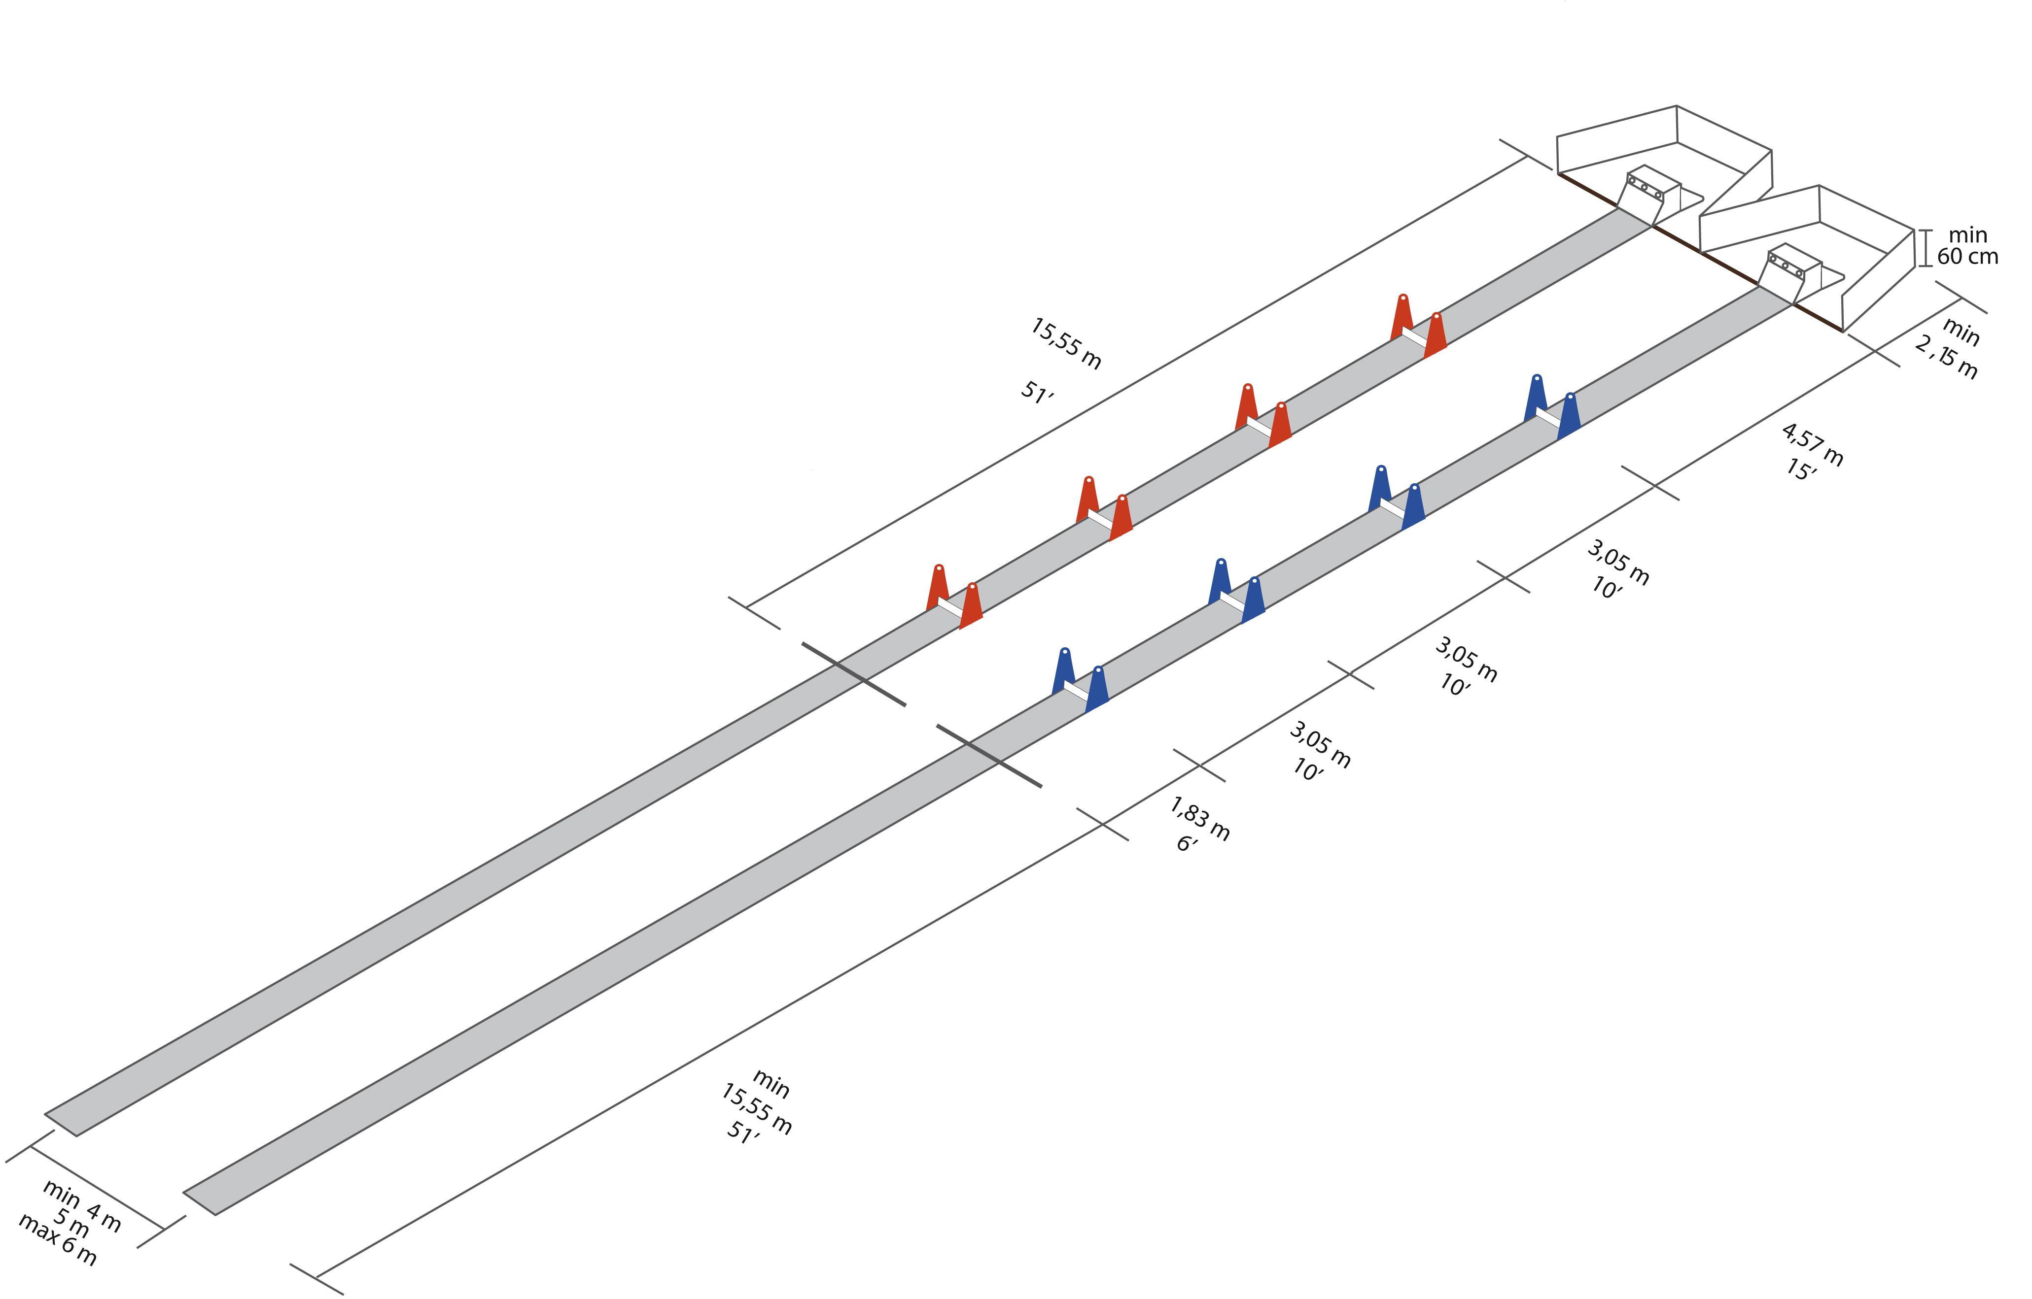

ANNEX 2 Flyball box

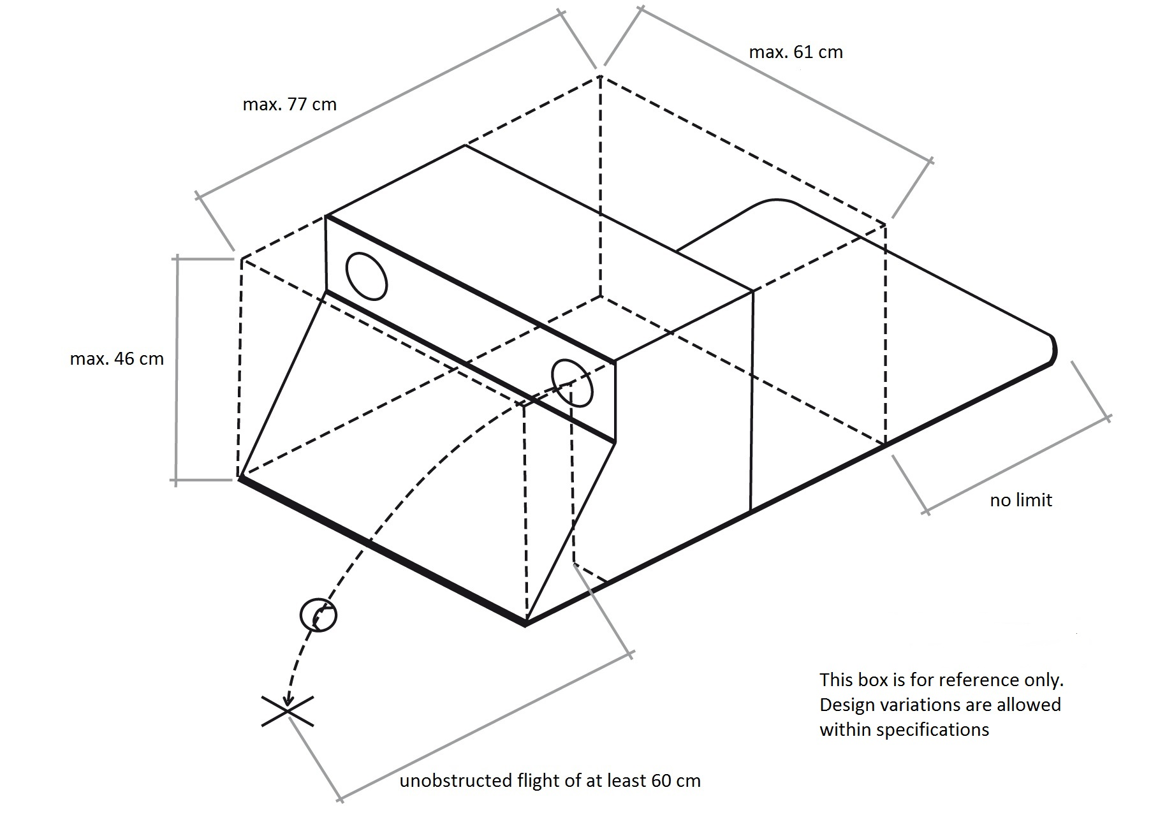

ANNEX 3 Measurement

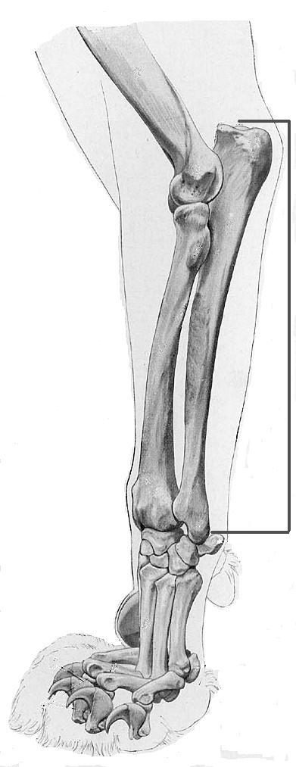

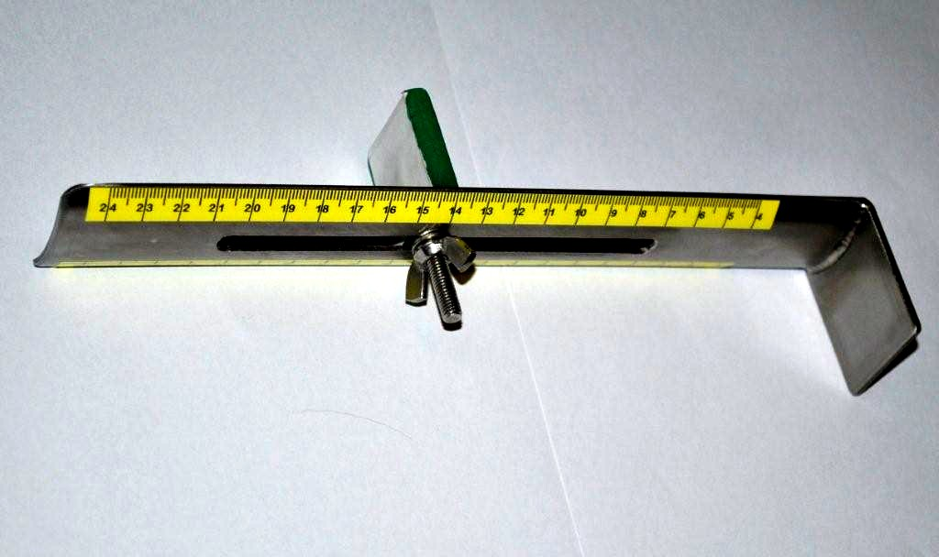

ANNEX 4 Technical description electronic judging system EJS

The Electronic Judging System is used for measuring the time of the races and to properly evaluate the passes and starts. The system consists of minimal a semaphore with starting sequence and two gates with sensors. A display shall be provided at the timing table showing the elapsed time for each lane.
The EJS sensor panels should be placed such that the entering sensors are placed directly on the start/finish line with the exiting sensors placed closer to the box line. Sensor gates should be placed a minimum of 100 cm apart but no more than 150 cm apart. The light tree shall be placed directly between the racing lanes, shall not create any obstruction and should be clearly visible for all judges and competitors, including the box loader.

The system must meet the following minimal requirements:

Sensors Physical:
• lowest beam no more than 203 mm from ground
• highest beam no lower than 711 mm
• maximum vertical beam spacing 101 mm
• passing fault sensors shall be 152 mm from the start/finish line toward the first hurdle
• if two columns of beams are used the beams must be at the same heights
• able to span at least 150 cm

Light tree Physical:
• Bottom light shall be at least 60 cm above the ground.
• Must have an independent light for each lane used to indicate pass fault and false start.
• There must be a sequence of at least three yellow (or red and two yellow) lights directly above a green for the starting sequence.
• There should be an independent light for each dog used to indicate dog faults during each heat.
• Some indication should be provided that the system is ready for the judge to start a heat.

Accuracy/precision:
• The timing system shall time the heat to the thousandth of a second.
• The timing system shall display the time down to at least the hundredth of a second (xxx.xx).
• Rounding shall be used if converting from timing in thousandths to display in hundredths.
• A tie shall be indicated if the measured times in the two lanes are equal.
• The timing system must be precise to within 3ms (all system latencies combined).
• The timing system shall be accurate to within 3ms over 60 seconds (50 ppm).
• The timing system shall provide the same timing for both lanes to within 2ms over 60 seconds.
• Sensors electrical latency shall not exceed 2ms and if scanned, scan latency shall not exceed 1ms.
• System shall sample the sensors such that a solid object moving horizontally through the sensors at 50 fps would be seen to break each beam in a separate sample or 1 sample/ms whichever is faster (i.e. horizontal spacing 6", 50fps means the object will cross the two columns in .01 seconds -- .001 is smaller -- must sample at 1/ms).

Operation:
• The system shall become ready and wait for the start of a heat
• The head judge or designate will indicate a heat start to the system
• The system shall refuse to start the heat if the sensors are misaligned.
• Head or line judge press START button
• The system activates the sequence of red + yellow lights followed by the green light at 1.0 second intervals.
• The green light shall signal the start of the timer.
• If a beam is broken before the start of the timer, a false start shall be indicated.
• The beam column closest to the start/finish line shall be the line beam.
• The beam column closest to the first hurdle shall be the passing beam.
• Once the timer has started, each time the line beam is broken ("safe" or not), an updated elapsed time shall be shown.
• Each time the passing beam is broken or cleared, the line beam shall be "safe" for 2 seconds.
• If the line beam is broken while not "safe" a pass fault shall be indicated for at least 2 seconds.
• The head judge or designate will indicate a heat completion to the system.
• Once a heat is complete, nothing will alter the displayed times (beam breaks are ignored).
• Once the timing table has copied the necessary information (times), they shall indicate readiness for a new heat to the system.
• The judge cannot start a new heat until the timing table indicates readiness to the system.

ANNEX 5 World record form - application

In order that the record can be approved, all rules of the F.C.I. flyball should have been respected and the competition should have been judged by a head judge officially recognized by an N.C.O. All obligations according to F.C.I. Flyball regulation Section 1.12 should be satisfied before racing can continue.

Date: ………… Name of tournament, place, country : …………………………………………….…

Ring no.: ……… Division: ……… Race n°: ……… Heat n°: ……… Surface : ..........................

Head judge: ….................………………… Responsible organizer: ……………….…………………..

Achieved time: ...... . ......

Team: …………………………………………… F.C.I. Association : ......................... .........................

Jump height set (cm): ….……… Captain: …….……………….. Box loader: ……….………………..
Dog name | Breed | Jump Height | Licence N° | Handler
For verification of the record the Head Judge checked and measured:
Lane measurement Box checking
 | Lenght of lane |  | Throw of balls of all sizes from all holes
 | Jump height |  | Placement
 | EJS Alignment |  | Box dimensions

Others : ................................................................

I, ……………..........……, as head judge hereby confirm, that all obligations according to F.C.I. regulation 1.12 have been met and verified by myself. Full Name: .........................................................................
F.C.I. - N.C.O.: .........................................................................
Signature: .........................................................................

I, ……………..........……, as a responsible organizer of above mentionned tournament hereby confirm, that this form was filled in accordance with reality, correctly and truthfully.
Name: .........................................................................
F.C.I. – N.C.O. - Association: .........................................................................
Signature: .........................................................................
This form has to be duly completed and send from the N.C.O. concerning towards the president of the F.C.I. flyball commission. The record will be recognized after acceptance by the F.C.I. flyball commission.

